**AT Protein A Diamond**

**Affinity chromatography resin**

**Instruction for Use**

Bestchrom (Shanghai) Biosciences Ltd.

**Contents**

1. Introduction 1

2.Technical characteristics 1

3. Method of chromatographic 2

4. Application 5

5. Cleaning-in-place(CIP) 6

6. Alkali stability 6

7. Sterilization 6

8. Storage 6

9. Disposal and Recycling 7

10. Order information 7

# 1. Introduction

AT Protein A Diamond is A new type of affinity chromatography resin made by coupling alkali-resistant Protein A with high rigid agarose substrate through epoxy activation. Compared with traditional antibody affinity resin, the ligand is more stable, the flow velocity is faster, and the back pressure is lower. Suitable for capturing monoclonal antibodies or Fc fusion proteins from mass cell culture media and polyclonal antibodies from ascites or plasma.

The ligand of AT Protein A Diamond is the fragment of recombinant Protein A obtained by fermentation of *E.Coli*.During upstream construction, alkali-resistant amino acids were used to replace the non-alkali-resistant amino acids, and protease-sensitive amino acids were removed, so that the ligand has good alkali-stability. The ligand fermentation and subsequent purification processes use no animal raw materials. The resin can be cleaned in situ with 0.1~0.5M NaOH, avoiding the use of expensive and corrosive cleaning reagents, which can effectively save costs, and is easy to be used in industrial large-scale production.

# 2.Technical characteristics

|  |  |
| --- | --- |
| Appearance | White slurry, which can be layered |
| Matrix | High rigidity agarose |
| Particle size + | 40~120μm |
| Functional group | Recombinant Alkali Tolerant Protein A (24KD) |
| Cross-linking method | Epoxy chemistry |
| Dynamic binding capacity++ | ≥40mg human IgG/mL packed resin |
| Chemical stability | Stable in common aqueous buffers: 10mM HAc, 0.1M sodium citrate，6M GuHCl,8M Urea, 30%isopropyl alcohol, 20% ethanol. |
| Pressure flow velocity | ~500cm/h，BXK300，H=20cm，<2bar |
| Max. pressure | 0.5MPa |
| pH stability | 3~12(working) 2~13(CIP) CIP: 0.1~0.5M NaOH |
| Storage+++ | 2~8℃, 20% ethanol or 2% benzyl alcohol |
| Recommended flow velocity | 100~300cm/h |

+Particle size is normally distributed, and particles within this range account for more than 75% of the total.

++Linear flow velocity 100cm / h, column height 10cm, buffer conditions: 20mM PB, 0.15M NaCl, pH7.4

+++2% benzyl alcohol is only used for international transport or special requirements from customer

# 3. Method of chromatographic

3.1 Column packing

**Note：It is best to equilibrate the resin slurry to room temperature before column packing.**

* According the column volume to calculate the amount of resin.

Resin volume=column volume×1.15 (Compression factor=1.15)

According to the volume of the settlement resin required, the suspended slurry of the resin required is calculated by the follow:

Required resin slurry1 volume = Settlement resin volume ÷ Resin slurry 1 concentration. The original concentration of resin slurry 1 is shown in the follow table.

|  |  |
| --- | --- |
| Pack size | Resin slurry 1 concentration (%) |
| 25mL、100mL、500mL、1L、5L、10L | 80 |
| 20L、40L | 75 |

**1: It refers to the original packaging resin slurry sold by Bestchrom.**

**Note: For non-original packaging, customer can calculate the required volume according to the actual concentration of resin slurry.**

* Washing the resin: Suspend the resin by shaking and pour into a funnel, remove the liquid, and wash with about 3mL packing solution (20% ethanol with 0.4M NaCl)/mL resin for 3 times. Use a glass stick or stirrer to stir each time you add the packing solution, in order to better clean the shipping buffer.
* Prepare the packing slurry: Transfer the washed resin from the funnel into a beaker or other appropriate container, add packing solution to obtain a 45%~55% slurry, stir well and set aside for use.
* Take a cleaned BXK column (BXK series columns with diameters ranging from 1cm to 30cm can satisfy different scale chromatography applications). Take BXK16/20 for example, purge the bubbles trapped at the end-piece net by draining some packing solution through the column outlet. Leave about 1cm water at the bottom of the column and close the bottom outlet. Adjust the column so that it is perpendicular to the ground.
* Slowly pour the slurry into the column at one time (use a packing reservoir if necessary). Do not bring any air bubbles into the column.

**Packing reservoir: Empty glasstube with same diameter as the BXK column.**

* Fill the remainder of the column with packing solution. Connect the packing reservoir to the chromatography system, open the flow velocity, drain the bubbles in the hose, close the flow velocity, and tighten the top cover of the packing reservoir.
* After pouring, stir well again with Stirrer, and then wash the resin particles on the inner wall of the column from top to bottom with the packing solution, and let the resin settle naturally until there is about 1cm of clarifying solution on the suspension.Mount the adapter and connect the adapter to the chromatography system or peristaltic pump.Lower the adapter to descend to contact with the clarifying solution and tighten the sealing ring after it is fully immersed in the clarifying solution.With the outlet of the top piece is opened, slowly move the adapter down until all bubbles are drained.

**Note: This operation is only applicable to BXK 100 and above columns.Flushing the inner wall reduces the resin particles sticking between the seal ring and the column wall, avoiding the risk of leakage.**

* When the bed height is 10cm, the flow velocity can be set to 300cm/h. Open the bottom plug, start the pump and run the setting flow velocity until the bed is stabilized,mark the bed height.
* Remove the packing reservoir (if any), mount the adaptor, lower the adaptor to about 0.5cm above the resin surface, and continue to press the column using the above flow velocity until the bed is completely consolidated, mark the consolidated bed height.
* Stop the pump, open the top plug of adaptor, close the bottom plug, loosen the O-ring seal slightly, press the rubber surface according to the compression ratio of 1.15, tighten the O-ring seal, close the outlet, and complete the column packing.

3.2 Evaluation of Packing

* The packing quality of chromatographic column can be confirmed by column efficiency measurement and evaluation.The tests are required after the column packing, during the column working life and when the separation and purification performance weakens. The method usually relies on the height equivalent to a theoretical plate(HETP) and the asymmetry factor(As).
* Acetone or NaCl solution can be used as sample for the testing. Sample solution and mobile phase can be prepared according to the following table.

Acetone method NaCl method

|  |  |  |
| --- | --- | --- |
| Sample | 1.0% (v/v)acetone in water | 0.8M NaCl in water |
| Sample volume | 1.0%CV | 1.0%CV |
| Mobile phase | Water | 0.4M NaCl in water |
| Flow velocity | 30cm/h | 30cm/h |
| Monitor | UV280 nm | Conductivity |

* Method for measuring HETP and As:

Use UV curve or the conductivity curve to calculate the height equivalent of theoretical plate (HETP), number of theoretical plates(N) and the asymmetry (As):

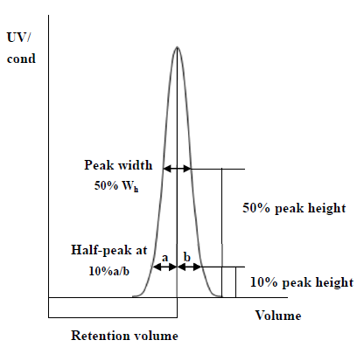HETP=L/N

N=5.54(VR/Wh)2

Note: VR = retention volume

Wh = half-peak width

L = column height

N = the number of theoretical plates

(The units of VR and Wh should be the same)

As=b/a

Note:

a= 1st half peak width at 10% of peak height

b= 2nd half peak width at 10% of peak height

* Evaluation the column packing

As a guideline, if the value of HETP is less than 3 times the average particle size(d50) of the resin and the As is between 0.8~1.8, the column is very efficient. The unsatisfactory results should be analyzed and the column should be repacked .

3.3 Chromatographic method

* Buffer：Usually use neutral buffer as the binding buffer (eg: 50mM PB 0.15M NaCl pH7.0-7.6). Use low pH buffer as eluent (eg 0.1M citric acid pH3.0-4.0). Since the ability of AT Protein A to bind to IgG depends on the source and subtype of antibody (Table 1), high salt and high pH can promote the binding of antibody and resin. And reduce non-specific binding, increase pH, and neutralize the relative histidine residues of the alkali-resistant Protein A and IgG binding sites. The electrostatic repulsion effect of these residues hinders the affinity reaction. Increase the salt concentration to reduce electrostatic repulsion and enhance the hydrophobic effect. For different antibodies, the binding conditions and washing conditions can be optimized by changing the salt type, concentration and pH of the buffer. When optimizing the elution conditions, it is necessary to explore the maximum pH for effective desorption.

When optimizing the elution conditions, it is necessary to explore the maximum pH for effective desorption to avoid denaturation of unstable antibodies when the pH is too low.

Table 1. Comparison of affinity of AT Protein A for specific subtype monoclonal antibodies

|  |  |  |  |
| --- | --- | --- | --- |
| Antibody | Affinity | Combine pH | Elution pH |
| **Human** |  |  |  |
| IgG1 | Very high | 6.0-7.0 | 3.5-4.5 |
| IgG2 | Very high | 6.0-7.0 | 3.5-4.5 |
| IgG3 | Low-non | 8.0-9.0 | ≤7.0 |
| IgG4 | Low-high | 7.0-8.0 | 3.0-6.0 |
| **Mouse** |  |  |  |
| IgG1 | Low | 8.0-9.0 | 4.5-6.0 |
| IgG2a | Resin | 7.0-8.0 | 3.5-5.5 |
| IgG2b | High | ≥7.0 | 3.0-4.0 |
| IgG3 | Low-High | ≥7.0 | 3.5-5.5 |

* Flow velocity: According to the height of the column, a linear flow velocity of 100 ~ 300cm/h is generally selected. The higher the column height, the slower the flow velocity.
* Sample preparation: In order to prevent the sample from clogging the column, the sample needs to be filtered with a 0.45μm microporous membrane before loading, and the pH and conductivity of the sample are adjusted to be consistent with the equilibrium buffer. The lower the flow velocity, the higher the dynamic binding capacity.
* Equilibration: Washing the column with equilibration buffer, which usually needs 3-5CV.
* Sampling: The loading volume is determined according to the substance content and binding load of AT Protein A Diamond.
* Rinse: After loading, the uv absorption is reduced to the appropriate value by the balance buffer. If necessary, high salt or slightly lower pH can be added to clean the non-specific adsorption impurities as much as possible.
* Elution: A linear gradient of 10CV from equilibrium solution to elution buffer (e.g. 1M sodium citrate, pH3.0) can be used to determine the optimal pH of elution according to the peak position of antibody.If the antibody is unstable under acidic conditions, the eluent can be neutralized with a neutralizing solution (e.g. 1.0M Tris-HCl, pH9.0).

**4. Application**

AT Protein A Diamond purification of a CHO expressed antibody

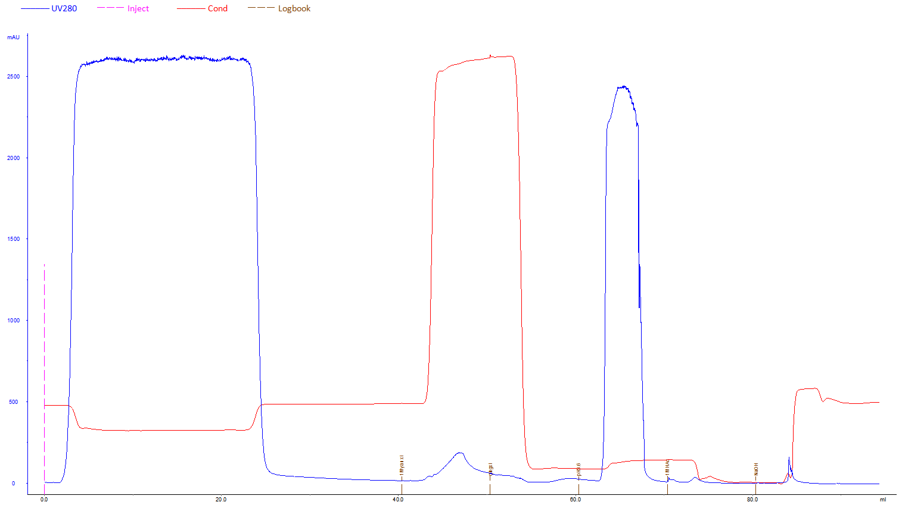

Column: BHR5/100

Bed height: 10cm

Sample: CHO fermentation monoclonal antibody

Loading quantity of sample：80% of 10% dynamic load

Buffer solution： A：PBS

B：50mM NaAc，1M NaCl pH5.5

C：50mM NaAc pH5.5

D：50mM NaAc pH3.6

E：1M HAc

F：0.1M NaOH

Flow velocity： 0.33mL/min

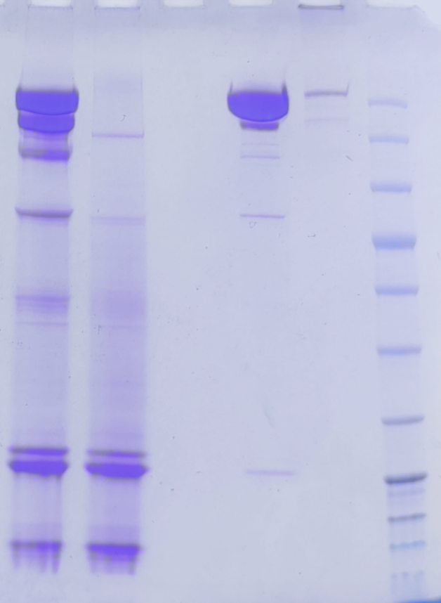

Lane 1：Original sample

Lane 2：Flow through

Lane 3：Rinse

Lane 4：Elution

Lane 5：0.1 M NaOH to wash

1 2 3 4 5

**5. Cleaning-in-place(CIP)**

With the increasing use of chromatography resin, the accumulation of contaminants on the chromatography column is also increasing. Cleaning-in-place can prevent the accumulation of contaminants and maintain a stable working state. Determine the frequency of CIP according to the degree of contamination of the resin (if the contamination is serious, CIP should be carried out after each use to ensure repeatability of the results).

* 2M NaCl can be used to wash 2CV to remove strong non-specifically bound proteins.
* Then wash the column with 0.1-0.5M NaOH, residence time 10-15min.
* Immediately flush at least 5CV with binding buffer.

**6. Alkali stability**

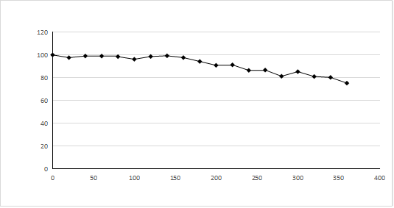

**10%IgG DBC**

**Cycle**

AT Protein A Diamond with 0.1M NaOH CIP (residence time: 33.52min) for 10%IgG dynamic load.

**7. Sterilization**

Since 20% ethanol or 2% benzyl alcohol preservation solution does not have sterilization and depyrogenation effects, it is recommended that AT Protein A Diamond resin can be treated with 0.1M NaOH for 30min or 0.5M NaOH for 15min to reduce the risk of microbial contamination before and during use.

**8. Storage**

AT Protein A Diamond is supplied in 20% ethanol or 2% benzyl alcohol. It should be stored in 20% ethanol and sealed at 2-8℃ after use, in order to prevent ethanol volatilization and microbial growth, it is recommended to replace the storage solution every 3 months.

**9. Disposal and Recycling**

AT Protein A Diamond is very difficult to degrade in nature, incineration is recommended to protect the environment.

# 10. Order information

|  |  |  |
| --- | --- | --- |
| Product | Code No. | Pack size |
| AT Protein A Diamond | AA0272 | 25mL |
| AA0273 | 100mL |
| AA0274 | 500mL |
| AA0275 | 1L |
| AA0276 | 5L |
| AA0277 | 10L |
| AA302315 | 20L |

|  |  |  |
| --- | --- | --- |
| Prepacked columns | Code No. | Pack size |
| EzFast AT Protein A Diamond | EA302301 | 1×1mL |
| EA302303 | 1×5mL |
| EA302351 | 5×1mL |
| EA302353 | 5×5mL |
| EzScreen AT Protein A Diamond | EA02725 | 1×4.9mL |
| EA02735 | 5×4.9mL |
| EzLoad 16/10 AT Protein A Diamond | EA302304 | 1 pcs |
| EzLoad 26/10 AT Protein A Diamond | EA302306 | 1 pcs |